HD2dC06w – Customer CRUD Application

|  |  |
| --- | --- |
| **Product and Focus**  HANA Platform/oData | **MOTIVATION**  This case describes the user of oData services to implement CRUD operations.  **PREREQUISITES**  HD1C01 – Hello World MVC App  HD1dC02 – Create the Persistence Model  HD1dC03 – oData Services |
| **Target Audience**  Undergrduate/Graduate Beginner to Intermediate |
| **Author**  Ross Hightower |
| https://bgoerke.files.wordpress.com/2013/05/section1.png | |

# Customer CRUD Application

This cases builds on the previous two cases in this series to develop an application which allows the user to create, update and delete customers.

## Create the Application Packages

Logon to the WDW and locate the gbi package you created in case HD1dC2w. Right-click the gbi package and choose **Create Application.** Choose the SAP UI5 Hello World Template and then add **CRUD** to the Package.

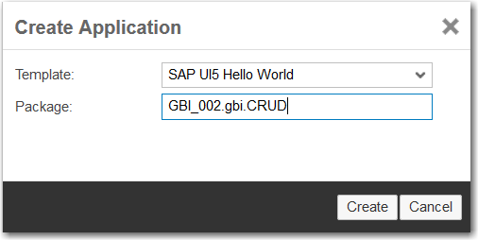

The package is created and basic application is created.

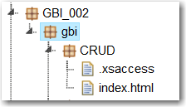

Note there is no .xsapp file. That file is unnecessary because in the previous case we created that file in the gbi package. It applies to the entire directory structure below it. However, the .xsaccess file was created because it is possible to create different levels of access for different packages.

You can run the application if you want by selecting the index.html file and clicking . This is the standard SAPUI5 Hello World app.

Now create the **view** package shown in the image below.

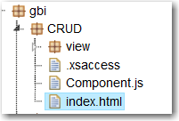

The basic structure of the application is complete. Now let’s add some content.

## Create the Application

The application follows a standard structure for an SAPUI5 application. The index.html file bootstraps the SAPUI5 libraries and creates a Component which encapsulates the application. The definition of the component is included in a file called Component.js. The name and location of this file is standard and cannot be altered. The various view and controller files are located in a package called view. For this application we will also load css file to illustrate how to use CSS styles.

### index.html

Replace the code in the index.html file with this code.

|  |
| --- |
| <!DOCTYPE html>  <html>  <head>  <meta http-equiv="X-UA-Compatible" content="IE=edge" />  <meta charset="UTF-8">  <title>Customer CRUD App</title>    <!-- Bootstrap the SAPUI5 libraries and create the namespaces for the application -->  <script id="sap-ui-bootstrap"  type="text/javascript"  src="/sap/ui5/1/resources/sap-ui-core.js"  data-sap-ui-theme="sap_bluecrystal"  data-sap-ui-libs="sap.m"  data-sap-ui-resourceroots = '{  "gbi" : "./"  }'>  </script>  <!-- Load the component defined in the Component.js file -->  <script>  new sap.ui.core.ComponentContainer({  name: "gbi"  }).placeAt("content")    </script>  </head>  <body class="sapUiBody" id="content">  </body>  </html> |

Listing 1

For an explanation of this code see case HD1C01 – Hello World MVC.

### Component.js

Create the Component.js file in the CRUD package and add the following code.

|  |
| --- |
| jQuery.sap.declare("gbi.Component");  sap.ui.core.UIComponent.extend("gbi.Component", {  createContent : function() {  // create root view  var oView = sap.ui.view({  id : "app",  viewName : "gbi.view.App",  type : "JS",  viewData : { component : this }  });  return oView;  }  }); |

Listing 2

For an explanation of this code see case HD1C01 – Hello World MVC.

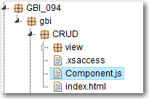

### App.view.js

Create the App.view.js file in the view package and add the following code.

|  |
| --- |
| sap.ui.jsview("gbi.view.App", {    createContent: function (oController) {    // to avoid scroll bars on desktop the root view must be set to block display  this.setDisplayBlock(true);    // create app  this.app = new sap.m.App();    // load the master page using an XML view  var customer = sap.ui.xmlview("Customers", "gbi.view.Customers");  this.app.addPage(customer, true);    // done  return this.app;  }  }); |

Listing 3

This code creates the App control which defines the overall structure of the interface which, unlike the previous cases that use a SplitApp control, is a full screen application. Also unlike the previous cases, there is no need for navigation in this case so there is no router in the Component.js file and the main view of the application (Customers) is loaded in the App.view.js file.

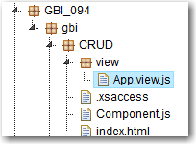

### Edit.fragment.xml

Create a file called Edit.fragment.xml in the view folder and add the following code.

|  |
| --- |
| <core:FragmentDefinition  xmlns="sap.m"  xmlns:l="sap.ui.layout"  xmlns:f="sap.ui.layout.form"  xmlns:core="sap.ui.core"  xmlns:c="sap.ui.commons">  <l:Grid  defaultSpan="L12 M12 S12"  width="auto">  <l:content>  <f:SimpleForm id="idEditForm"  minWidth="1024"  maxContainerCols="2"  editable="true"  layout="ResponsiveGridLayout"  title="Customer Information"  labelSpanL="2"  labelSpanM="2"  emptySpanL="4"  emptySpanM="4"  columnsL="2"  columnsM="1"  class="editableForm">  <f:content>  <core:Title text="Company" />  <Label text="Customer No." />  <Text id="idCustomerID"  text="{edit>ID.CustomerID}" />  <Label text="Company Name:" />  <Input id="idCompanyName"  maxLength="35"  value="{edit>CompanyName}" />  <Label text="Sales Org" />  <Input id="idSalesOrg"  maxLength="4"  value="{edit>SalesOrgID}" />  <core:Title text="Address" />  <Label text="Address" />  <Input id="idAddress"  maxLength="35"  value="{edit>Address.Address}" />  <Label text="City" />  <Input id="idCity"  maxLength="20"  value="{edit>Address.City}" />  <Label text="Region" />  <Input id="idRegion"  maxLength="2"  value="{edit>Address.Region}" />  <Label text="Postal Code" />  <Input id="idPostalCode"  maxLength="5"  value="{edit>Address.Postal_code}" />  <Label text="Country" />  <Input id="idCountry"  maxLength="5"  value="{edit>Address.Country}" />  </f:content>  </f:SimpleForm>  </l:content>  </l:Grid>  </core:FragmentDefinition> |

Listing 4

This code implements a SimpleForm control that allows the user to edit customer data. Fragments are blocks of code that can be loaded dynamically by SAPUI5. This form will be used to edit a customer and will be loaded when the user clicks the Edit button.

### Display.fragment.xml

Create a file called Display.fragment.xml in the view folder and add the following code.

|  |
| --- |
| <core:FragmentDefinition  xmlns="sap.m"  xmlns:l="sap.ui.layout"  xmlns:f="sap.ui.layout.form"  xmlns:core="sap.ui.core">  <l:Grid  defaultSpan="L12 M12 S12"  width="auto">  <l:content>  <f:SimpleForm id="idCustomerForm"  minWidth="1024"  maxContainerCols="2"  editable="false"  layout="ResponsiveGridLayout"  title="Customer Details"  labelSpanL="4"  labelSpanM="4"  emptySpanL="0"  emptySpanM="0"  columnsL="2"  columnsM="2">  <f:content>  <core:Title text="Customer" />  <Label text="Number" />  <Text text="{gbi>ID.CustomerID}" />  <Label text="Company" />  <Text text="{gbi>CompanyName}" />  <Label text="Sales Org" />  <Text text="{gbi>SalesOrgID}" />  <core:Title text="Address" />  <Label text="Address" />  <Text text="{gbi>Address.Address}" />  <Label text="City" />  <Text text="{gbi>Address.City}" />  <Label text="Region" />  <Text text="{gbi>Address.Region}" />  <Label text="Postal Code" />  <Text text="{gbi>Address.Postal_code}" />  <Label text="Country" />  <Text text="{gbi>Address.Country}" />  </f:content>  </f:SimpleForm>  </l:content>  </l:Grid>  </core:FragmentDefinition> |

Listing 5

This code implements a SimpleForm control that displays customer data. Unlike the form in Edit.fragment.xml, this form uses Text controls rather than Input controls. This fragment is loaded dynamically when the application first loads and when the user clicks cancel or save while editing.

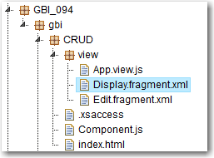

### Customers.view.xml

Create the Customers.view.xml file in the view package and add the following code.

|  |
| --- |
| <mvc:View width="100%" controllerName="gbi.view.Customers" xmlns="sap.m"  xmlns:l="sap.ui.layout" xmlns:core="sap.ui.core" xmlns:f="sap.ui.layout.form" xmlns:mvc="sap.ui.core.mvc" >  <Page title="GBI Customers" id="idPage">    <VBox width="80%" fitContainer="true" justifyContent="Center">    <l:Grid  id="idGrid"  defaultSpan="L10 M12 S12"  width="auto">  <l:content>  </l:content>  </l:Grid>    <Table id="idCustomersTable"    inset="true"  items="{gbi>/Customers?$orderby=ID.CustomerID}"  itemPress = "handleTableRowPress">  <columns>  <Column>  <header>  <Text text="Customer No." />  </header>  </Column>  <Column>  <header>  <Text text="Company" />  </header>  </Column>    <Column>  <header>  <Text text="Sales Org." />  </header>  </Column>  </columns>  <items>  <ColumnListItem type="Navigation">  <Text text="{gbi>ID.CustomerID}" />  <Text text="{gbi>CompanyName}" />  <Text text="{gbi>SalesOrgID}" />  </ColumnListItem>  </items>  </Table>  </VBox>  <footer>  <Bar>  <contentRight>  <Button id="create" text="Create" press="handleCreatePress" />  <Button id="edit" text="Edit" press="handleEditPress" />  <Button id="delete" text="Delete" type="Reject" visible="false" press="handleDeletePress" />  <Button id="save" text="Save" type="Emphasized" visible="false" press="handleSavePress" />  <Button id="cancel" text="Cancel" visible="false" press="handleCancelPress" />  </contentRight>  </Bar>  </footer>  </Page>  </mvc:View> |

Listing 6

This code implements the main interface of the application. There are two main parts of the interface. These are organized using a VBox control which is used to arrange elements vertically. The first part inside the VBox control is a Grid control. This control is a placeholder into which the Edit and Display fragments are inserted. The code that inserts the fragments is contained in the Customers.controller.js file.

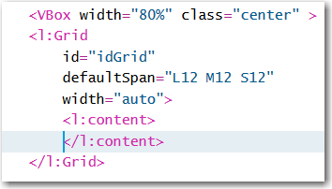

The second part is a Table control that is bound to the Customers entity. This is an aggregation binding, because it will return multiple objects. The Table’s aggregation binding is items so an item (defined below) will be created for each object returned by the service.

The itemPress event is fired when the user clicks an item in the table. This is assigned to a function called handleTableRowPress which will be defined in the Customers.controller.js file. Within the Table control the columns are defined…

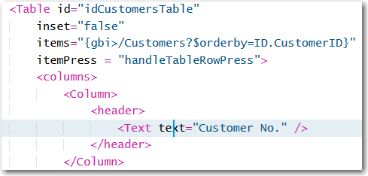

…and then the row structure is defined as items.

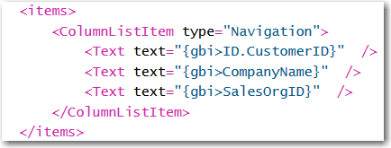

Finally, the footer of the page is defined. Note that three of the Buttons will not be visible when the application loads.

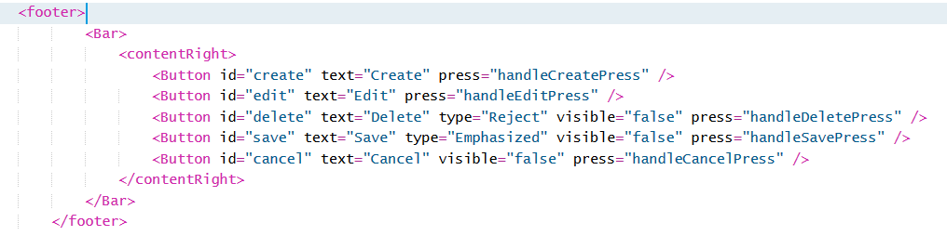

### Customers.controller.js

Create the Customers.controller.js file in the view package and add the following code to it.

|  |
| --- |
| //Load some libraries  jQuery.sap.require("sap.m.MessageToast");  jQuery.sap.require("sap.m.MessageBox");  sap.ui.controller("gbi.view.Customers", {    onInit : function(){  //Create the model and assign it to the view  var oModel = new sap.ui.model.odata.ODataModel("http://hana.ucc.uwm.edu:8004/GBI_002/gbi/services/gbi.xsodata");  this.getView().setModel(oModel,'gbi');    //This model will be used to bind to the edit or create form  var jModel = new sap.ui.model.json.JSONModel("");  this.getView().setModel(jModel,'edit');    //Load the display fragment  this._showFormFragment("Display");  },    handleTableRowPress : function(oEvent){  //When a table row is clicked, get its binding context and set the display form's binding context  var context = oEvent.getParameter("listItem").getBindingContext('gbi');  this.getView().byId("idCustomerForm").setBindingContext(context,'gbi');  },    handleEditPress : function () {  //Create a flag so we know that a customer is being edited  this.editFlag = true;  //Clone the data so we can cancel the changes if necessary  this._oCustomer = jQuery.extend({}, this.getView().byId("idCustomerForm").getBindingContext('gbi').getObject());    //Add the object ot edit to the edit model  this.getView().getModel("edit").setData(this._oCustomer);    //Save the binding context of the display form so we can reset it if necessary  this._context = this.getView().byId("idCustomerForm").getBindingContext('gbi');  //Save the binding path so we can perform puts and posts  this._sPath = this.getView().byId("idCustomerForm").getBindingContext('gbi').sPath.slice(1);    this._toggleButtonsAndView("Edit");  },  handleCancelPress : function () {  //Restore the data  var oModel = this.getView().getModel('gbi');  //Put back the original data  oModel.oData[this._sPath] = this._oCustomer;  this._toggleButtonsAndView("Display");  },  handleSavePress : function () {  //Retrieve the view's model  var oModel = this.getView().getModel('gbi');    //Create an object and add the customer properties to it from the form  var oEntry = {};    //Check whether the customer is being edited or created  oEntry["CompanyName"] = this.byId("idCompanyName").getValue();  oEntry["SalesOrgID"] = this.byId("idSalesOrg").getValue();  oEntry["Address.Address"] = this.byId("idAddress").getValue();  oEntry["Address.City"] = this.byId("idCity").getValue();  oEntry["Address.Region"] = this.byId("idRegion").getValue();  oEntry["Address.Country"] = this.byId("idCountry").getValue();  oEntry["Address.Postal_code"] = this.byId("idPostalCode").getValue();    if(this.editFlag){  oEntry["ID.CustomerID"] = this.byId('idCustomerID').getText();  //Perform a PUT  oModel.update('/' + this._sPath, oEntry, null, function(data){  sap.m.MessageToast.show("Update successful");  },function(data){  sap.m.MessageToast.show("Update failed");  });  } else {  oEntry["ID.CustomerID"] = 0;  //Perform a POST  oModel.create('/Customers', oEntry, null, function(data){  sap.m.MessageToast.show("Update successful");  },function(data){  sap.m.MessageToast.show("Update failed");  });  }  this._toggleButtonsAndView("Display");  },  handleDeletePress : function(){  //Confirm the user wants to delete the customer  var path = this._sPath;  sap.m.MessageBox.confirm(  "Are you sure you want to delete the customer?",  {  icon: sap.m.MessageBox.Icon.INFORMATION,  title: "Confirm Delete",  initialFocus: sap.m.MessageBox.Action.CANCEL,  onClose : function(oAction){  if(oAction === "OK"){  var oView = sap.ui.getCore().byId("Customers");  var oModel = oView.getModel("gbi");  oModel.remove('/' + path, null, function(){  sap.m.MessageToast.show("Delete successful");  },function(){  sap.m.MessageToast.show("Delete failed");  });  }  }  }  );  this._toggleButtonsAndView("Display");  },    handleCreatePress : function(){  //Create pressed so set editFlag to false  this.editFlag = false;  this._toggleButtonsAndView("Edit");  },    _formFragments: {},  _toggleButtonsAndView : function (form) {  var oView = this.getView();  if(form === "Edit"){  oView.byId("edit").setVisible(false);  oView.byId("create").setVisible(false);  oView.byId("save").setVisible(true);  oView.byId("cancel").setVisible(true);  oView.byId("delete").setVisible(true);  this._showFormFragment("Edit");  } if(form === "Create"){  oView.byId("edit").setVisible(false);  oView.byId("create").setVisible(false);  oView.byId("save").setVisible(true);  oView.byId("cancel").setVisible(true);  oView.byId("delete").setVisible(false);  this._showFormFragment("Edit");  } if(form === "Display"){  oView.byId("edit").setVisible(true);  oView.byId("create").setVisible(true);  oView.byId("save").setVisible(false);  oView.byId("cancel").setVisible(false);  oView.byId("delete").setVisible(false);  this._showFormFragment("Display");  }  },    _getFormFragment: function (sFragmentName) {  //Retrieve the form fragement from the _formFragments object  //If it has been created before it will exist in the object  var oFormFragment = this._formFragments[sFragmentName];    //If the form fragment has already been created, return it  if (oFormFragment) {  return oFormFragment;  }  //If it hasn't been created before load it from the file in the view package  oFormFragment = sap.ui.xmlfragment(this.getView().getId(), "gbi.view." + sFragmentName);  //Add it to the _formFragments object and return it  return this._formFragments[sFragmentName] = oFormFragment;  },  _showFormFragment : function (sFragmentName) {  //Get a reference to the grid control  var oGrid = this.getView().byId("idGrid");  //Delete the currrent content  oGrid.removeAllContent();  //Insert the new fragment  oGrid.insertContent(this._getFormFragment(sFragmentName));  //If the form is the edit form, set the binding context to the selected item in the table  if(sFragmentName === "Edit") {  //Create a context using the edit model  var oContext = new sap.ui.model.Context(this.getView().getModel("edit") , "/");  //Bind the edit form to the edit model  this.getView().byId("idEditForm").setBindingContext(oContext,"edit");  }  }  }); |

Listing 7

This is a complex controller. Review the comments in the code for an explanation. Much of the code is involved in switching between the two fragments and managing the display of the buttons.

## Test the Application

At this point you can test the Edit and Delete functions of the application. Before testing the Create operation, we will have to make some changes to the data model. Run the application and select an item on the table.

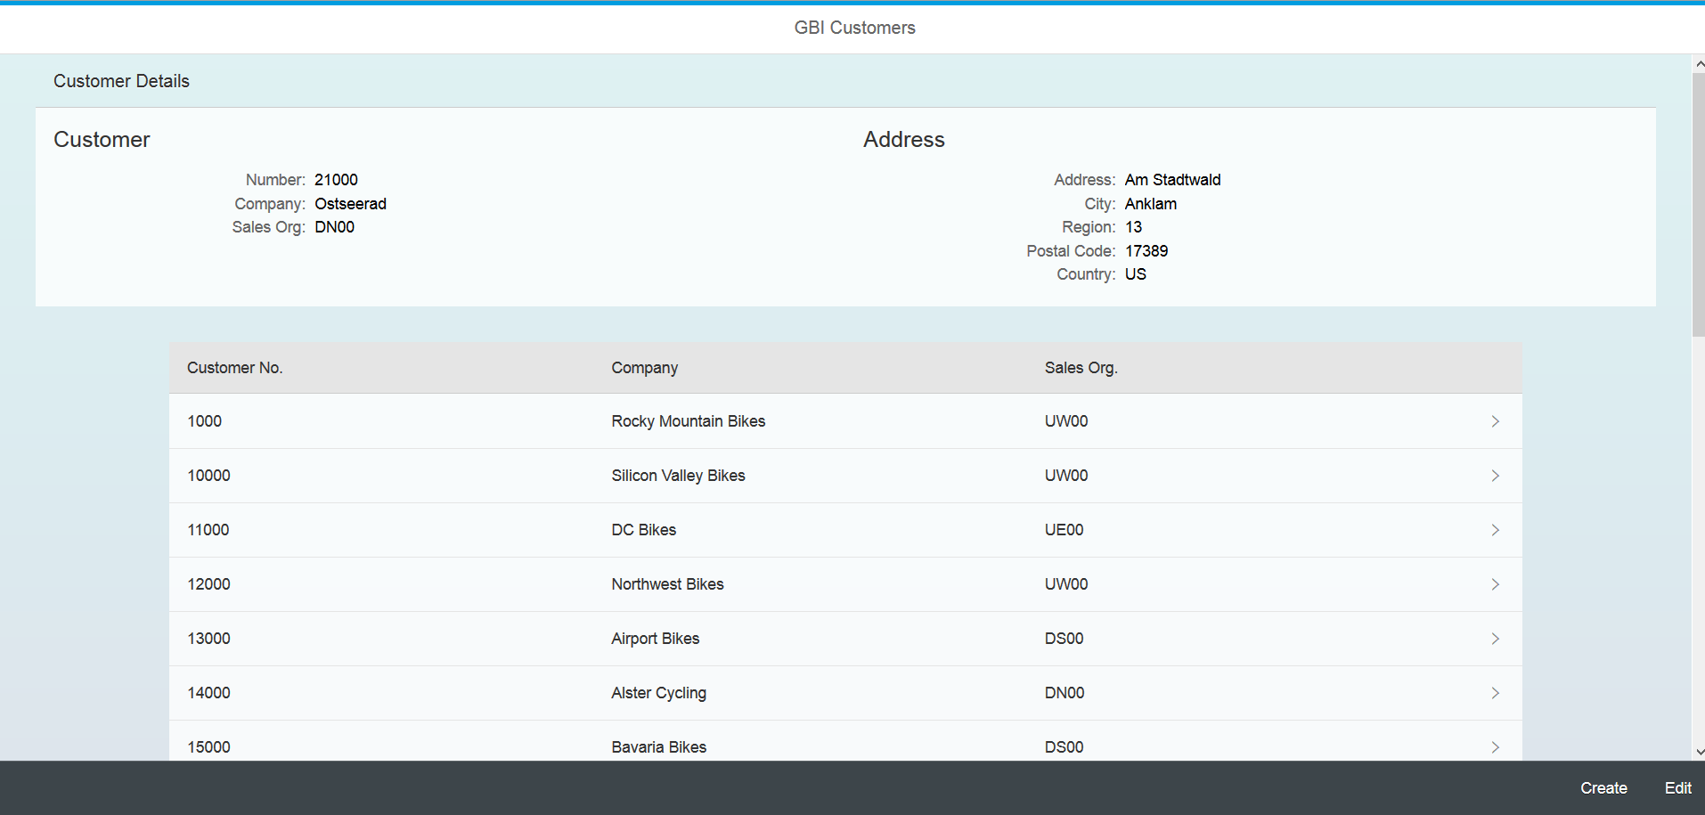

Click the Edit button and the edit form opens.

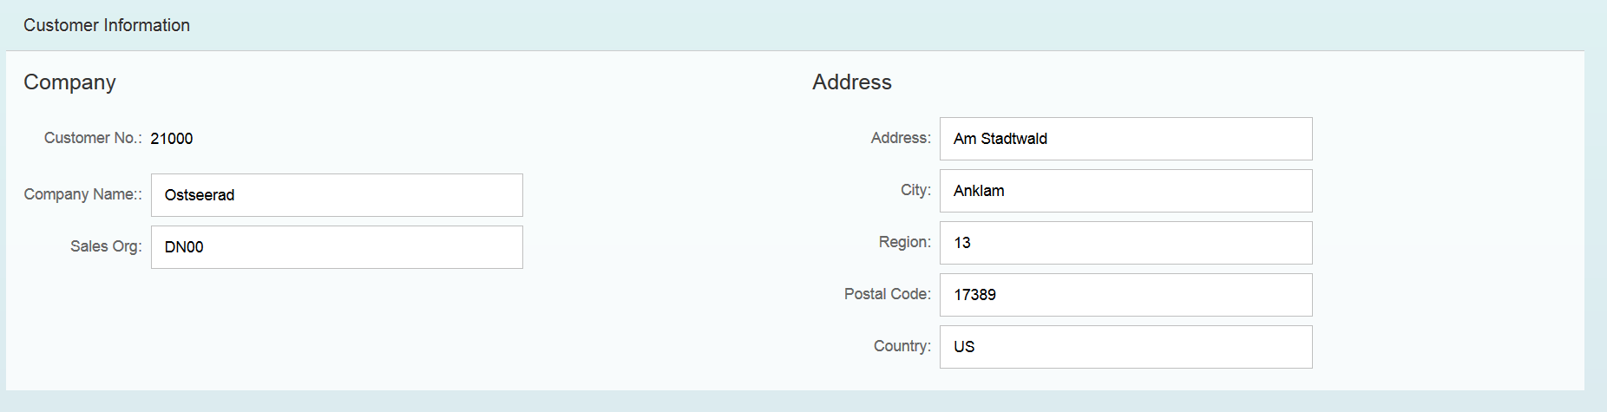

Edit the data and then click the Save button. A toast message will indicate the status of the update.



If you wish you can test the Delete operation as well.

## Implement the Create Procedure

As the application stands now you can create a customer but its ID will be 0 and you will not be able to create a second customer because the ID field is the primary key. In order to create multiple customers with valid ID fields we will use a sequence. A sequence will automatically choose the next value in a defined sequence each time it is invoked. To use a sequence we must create the sequence definition, bypass the oData customer create process with a SQLScript procedure and update the oData service to use the procudure when creating a customer.

### Define the Sequence

Create a file in the GBI_###\gbi\data package called **custoermid.hdbsequence**.

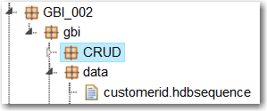

Enter the code shown below.

|  |
| --- |
| schema = "GBI_002";  start_with = 25000;  increment_by = 1000;  nomaxvalue = true;  nominvalue = true;  cycles = false; |

Listing 8

Update the highlighted code to use your schema name.

This will create a sequence that begins with the number 25000 and increments by 1000 each time. No min or max value are specified and the sequence will not cycle. It’s possible to set up a sequence that will cycle back to a min value when it reaches a max value.

### Create the Procedure

To use a procedure we must first create some table types that will contain the input and error values. Open the **GBI_###.hdbdd** file from the data package. Add the following code just inside the closing } at the bottom of the file. This creates a new context so make sure it is not inside the MASTERDATA, SALES or LOGISTICS contexts.

|  |
| --- |
| context procedures{    type custStructure {  ID : IDType;  CompanyName : String(35);  Address : AddressType;  SalesOrgID : OrgUnitIDType;  };    type errorsStructure {  HTTP_STATUS_CODE : Integer;  ERROR_MESSAGE : String(100);  DETAIL : String(100);  };  }; |

Listing 9

Notice the IDType custom data type for the ID field of the custStructure. We’ll define that type by adding the code shown below to the other custom types at the top of the file.

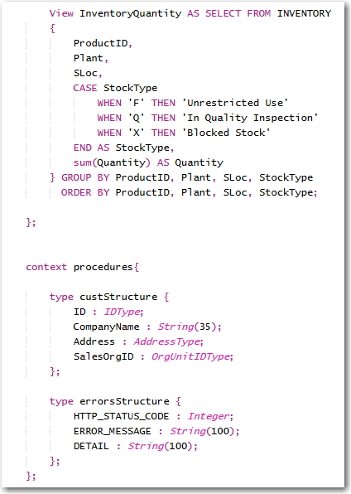

Notice the IDType custom data type for the ID field of the custStructure. We’ll define that type by adding the code shown below to the other custom types at the top of the file.

|  |
| --- |
| type IDType  {  CustomerID : String(10);  }; |

Listing 10

We must use this custom type because the ID field in the CUSTOMER field is a compound field (ID.CustomerID) because of the association with SALES_ORDERS. The code that defines the custStructure type does not allow compound field names.

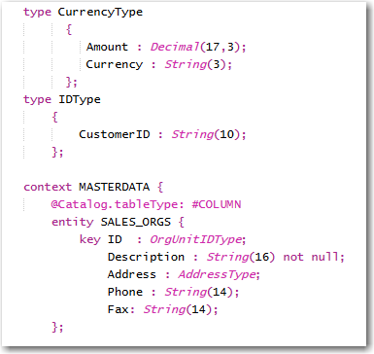

Now, create a package called **procedures** in the gbi package and create a file called **createCustomer.hdbprocedure** in the procedures package.

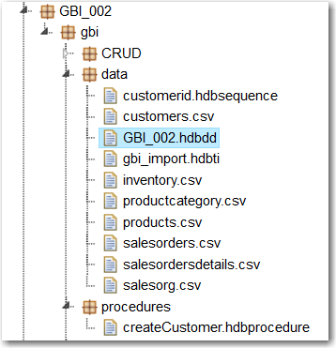

Copy the code below into the file.

|  |
| --- |
| PROCEDURE  "GBI_002"."GBI_002.gbi.procedures::createCustomer" (  IN intab "GBI_002.gbi.data::GBI_002.procedures.custStructure",  OUT outtab "GBI_002.gbi.data::GBI_002.procedures.errorsStructure"  )  LANGUAGE SQLSCRIPT  SQL SECURITY INVOKER AS  --DEFAULT SCHEMA <schema>  --READS SQL DATA AS  begin  declare lv_id string;  declare lv_companyname string;  declare lv_address string;  declare lv_region string;  declare lv_city string;  declare lv_country string;  declare lv_postalcode string;  declare lv_salesorg string;  select "ID.CustomerID", "CompanyName", "Address.Address", "Address.City", "Address.Country", "Address.Region", "Address.Postal_code", "SalesOrgID"  into lv_id, lv_companyname, lv_address, lv_city, lv_country, lv_region, lv_postalcode, lv_salesorg from :intab;  if :lv_companyname = '' then  outtab = select 500 as http_status_code,  'Company Name cannot be null ' as error_message,  ' No Way! CompanyName field must not be empty' as detail from dummy;  else  insert into "GBI_002.gbi.data::GBI_002.MASTERDATA.CUSTOMERS"  values ("GBI_002.gbi.data::customerid".NEXTVAL, lv_companyname, lv_address, lv_city, lv_country, lv_region, lv_postalcode, lv_salesorg);  end if;  end; |

Listing 11

Update the highlighted portions to reflect your id.

The first part of the code defines the name of the procedure. The first GBI_002 is the schema name. The portion GBI_002.gbi.procedures is the path to the createCustomer.ndbprocedure file.

The IN parameter is used to pass the input values to the procedure and makes use of the custStructure type you created above. Again, GBI_002.gbi.data is the path to the GBI_###.hdbdd file and GBI_###.procedures are the nested contexts in the GBI_###.hdbdd file.

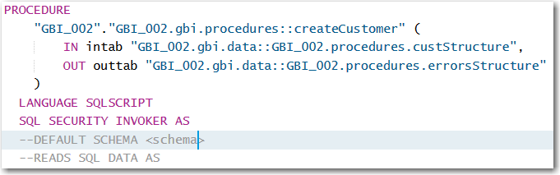

The next portion defines variables to hold the input values and then uses a SELECT statement to retrieve the input values from the intab input parameter.

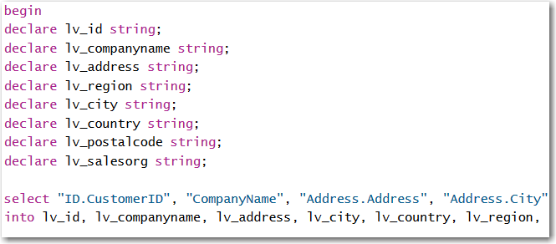

The CompanyName field cannot be null so the next step in the procedure is to make sure a value was passed in for CompanyName. If it wasn’t, an error is passed back to the application.

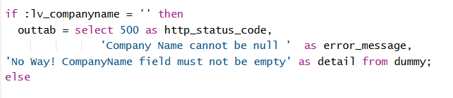

Finally, the record is inserted into the CUSTOMERS table.

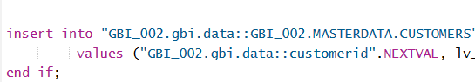

Note the reference to the customerid sequence for the ID field value.

If you look at your schema in the Catalog editor you will see the custom types, the sequence and the procedure.

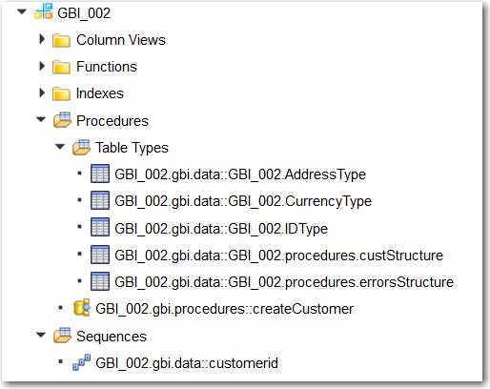

### Update the oData Service

Open the **gbi.xsodata** file and modify the Customers service as shown below.

|  |
| --- |
| "GBI_002.gbi.data::GBI_002.MASTERDATA.CUSTOMERS" as "Customers"  navigates ("CustomerOrders" as "Orders")  create using "GBI_002.gbi.procedures::createCustomer"; |

Listing 12

Now, you can create customers with the application and the sequence will insert a new value for the ID of each new customer.